**Experiment: 3**

PART A

(PART A: TO BE REFFERED BY STUDENTS)

**Aim:** **To study Switch case in C++ programming**

**Learning Outcomes: Learner would be able to**

1. Interpret the scenario to decide on selection blocks.
2. Explain using algorithm and flowchart conditional constructs as per scenario.

**Task 1: Identify the errors if any in the following codes without using codeblock and Justify you answer.**

1. #include <iostream>

void main() {

int choice = 2;

switch(choice);

{

case 1:

cout<<"Case 1\n";

break;

case 2:

cout<<"Case 2\n";

break;

case 3:

cout<<"Case 3\n";

break;

case 4:

cout<<"Case 4\n";

break;

default:

cout<<"Case default\n"; }

return 0;

}

1. #include <iostream>

void main()

{

    int a=2;

    int b=a;

    switch(b)

    {

        case a:

            cout<<"Case a \n"; break;

        case 3:

            cout<<"Case 3\n";     break;

        default:

            cout<<"No option\n";  break;

    }

    cout<<"Exit from switch";

}

1. #include <iostream>

int main()

{

char ch='b';

switch (ch)

{

case 'd':

cout<<"Case D ";

break;

case 'b':

cout<<"Case B ";

break;

case 'c':

cout<<"Case C ";

break;

case 'z':

cout<<"CaseZ ";

break;

default:

cout<<"Default";

}

return 0;

}

**Task2: Find the output of the following**

1. #include <iostream>

int main()

{

int num = 2;

switch (num + 2)

{

case 1:

cout<<"Case 1: ";

case 2:

cout<<"Case 2: ";

case 3:

cout<<"Case 3: ";

default:

cout<<"Default: ";

}

return 0;

}

1. #include <iostream>

void main()

{

    int a=10;

    switch(a){

        case 5+5:

            cout<<"Hello\n";

        default:

            cout<<"OK\n";

    }

}

1. #include<iostream>

int main()

{

switch(2/3)

{

case 1:

cout<<"case 1 executed ";

case 2:

cout<<"case 2 execcuted ";

break;

default:

cout<<"Default block executed";

}

return 0;

}

**Task 3:** Rewrite the following code segment using switch..case.

|  |  |
| --- | --- |
| if ( node == 15)  { curValue += 5;  Count++;  }  else if (node == 40)  { curValue *= 1.5;  Count++;  }  else  curValue -= 2; |  |
| if (grade == 'A')  cout<<"Very good";  else if (grade== 'B')  cout<<"Good";  else if (grade == 'C')  cout<<"Moderate";  else  cout<<"Try harder!"; |  |

**Task 4:** Write a C++ program to print the day of the week using switch case.

**Task 5:** Write a C++ program to implement a calculator (a|A for add, s|S for subtract, m|M for multiply, d|D for division) using switch case.

**Task 6:** Write a program to give a choice to user to perform below mathematical operations:

a. Finding a square root of number

b. Finding a power of a number

**Theory:**

Switch case is a [branching statement](https://codeforwin.org/2017/08/flow-control-statements-c.html#decision) used to perform action based on available choices, instead of making decisions based on conditions. Using switch case you can write more clean and optimal code than [if else statement](https://codeforwin.org/2017/08/if-else-statement-c.html). switch case only works with [integer, character and enumeration constants](https://codeforwin.org/2017/08/literals-c-programming.html). Switch case statements are a substitute for long if statements that compare a variable to several integral values.

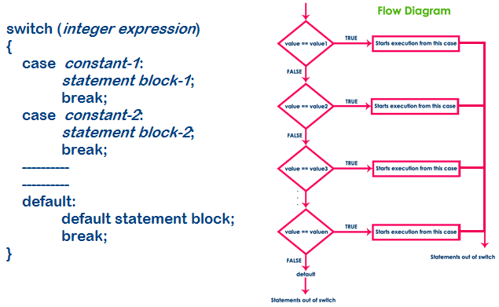

**Working of switch case statement:**

* The integer expression following switch is evaluated to an integer value.
* The integer value is matched one after the other with each of the case constant. When a match is found the statement block of the matched case is executed till break. On encountering break the switch statement is exited and controlled transferred after the switch statement.

**Rules to be followed:**

* It is necessary to include the break statement after every case statement block. If a break statement is not inserted in the case then the program not only executes the statements following the case where the match has been met, but also all the following case statements until break encountered or end of switch.
* The default statement is optional, it will be executed if the value does not match any of the case values.

PART B

(PART B: TO BE COMPLETED BY STUDENTS)

Students must submit the soft copy as per following segments within two hours of the practical. The soft copy must be uploaded on the portal at the end of the practical. The filename should be **PPS_batch_rollno_experimentno Example: PPS_B2_B001_Exp1**

|  |  |
| --- | --- |
| **Roll No.:** | **Name:** |
| **Prog/Yr/Sem:** | **Batch:** |
| **Date of Experiment:** | **Date of Submission:** |

**Task 1:**

**Task 2:**

**Task 3:**

**Task 4:**

**Task 5:**

**Task 6:**

**Conclusion (Learning Outcomes):** Reflect on the questions answered by you jot down your learnings about the Topic: Conditional Statement.

**Home Work Questions:**

1. Write an algorithm, draw a flowchart and write a C program to accept the percentage and print the grade A (90 to 100), B (80 to 90), C (50 to 80) and Fail below 50.
2. Write a C++ program to check whether input character is vowel or consonant.
3. Write a program to give a choice to user to find area of a shape – circle, rectangle, triangle, square